ABHISHEK VERMA

Address: 22A, Nature Huts-2, kharar-

140301

E-mail:

abhishekvermacu20

@gmail.com

Phone:

+91 8580880038

LinkedIn:

https://www.linkedin.com/in/d

ataanalyticsabhishek

PROFESSIONALSUMMARY

A well-organized, creative and goal-

possessing

good

graduate

oriented

problem-solving

and

communication,

leadership skills with a flair to explore

suitable avenues in Computer Science

Engineering while developing advanced

projects with efficiency and quality.

TECHNICAL COMPETENCIES

C++ | JAVA | PYTHON | WEB

DEVELOPMENT | DBMS |

SQL| GIT



INTERPERSONAL SKILLS

Team

Leadership

|

&

Management

Coordination

|

Decision Making

|

Good

|Problem

Solving

Communication skills

INTERESTS & HOBBIES

Travelling

|

Reading

|

Coding| Cooking

LANGUAGES KNOWN

English

|

Hindi

EDUCATION

Bachelors in Computer Science Engineering | Chandigarh University,

Gharuan

Session: 2020-2024 | Score: 7.28(up to 5

th

sem) CGPA

Matriculation (CBSE) |Aryan Public School, Sunni, Shimla

Session: 2017-2018 | Percentage: 82%

Intermediate (CBSE) | Aryan Public School, Sunni, Shimla

Session: 2019-2020 | Percentage: 63.83%

TRAINING & PROJECTS

**INTERNSHALATRAINING**

November 2021-Present

▪

Task is to Predict if the Client will Subscribe to Term Deposit using Python

It is project works on Logistic Regression and Decision Tree. It consists

of Data Science, Statistics, Predictive Modeling, Machine Learning.

We have a dataset of retail banking institution which includes client data

age, job type, marital status, duration of the call, day and month, etc.

**COLLAGE PROJECT | PNEUMONIA DETECTION SYSTEM**

April 2023-Present

▪

Designed an Web-site in which doctors can detect whether a patient

has Pneumonia or not using X-ray and past patient dataset.

This software use Image Processing (CNN) and Deep Learning.

ACADEMIC ACGIEVEMENT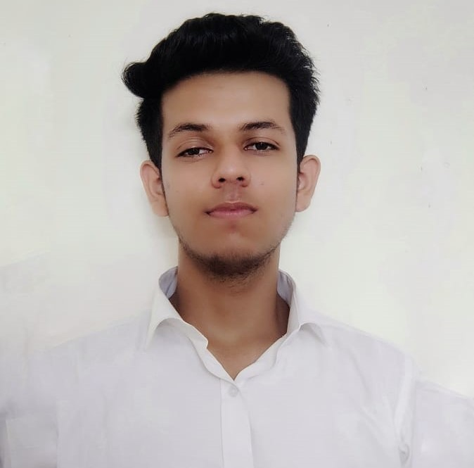DEMICACHIEVEMENTS

▪

Bronze Medal in School Level Science Olympiad.

▪

5 Start Coder in Hacker Rank.

CERTIFICATIONS& AWARDS

▪

Internshala training passed with 100% score.

▪

Web Development Certification from Coursera.

EXTRA CURRICULAR & CO-CURRICULAR ACHIEVEMENTS

▪

Participation in Cluster Level Badminton competition

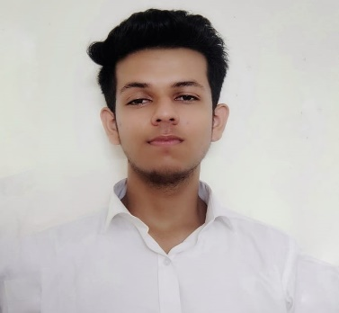

on Wikipedia, playing games, crack jocks and many more.

Its task is to write emails, playing youtube, music, searching information

Designed a Virtual Assistant using Speech Recognition Module

▪

June 2022-Present

**RIO – AI VOICE ASSISTANT**

▪

First position in Inter School Group Dance Competition.